**Hoda Magdy Mahmoud Elsayed**

**1. Create a user account with the following attribute**

**• username: islam**

**• Fullname/comment: Islam Askar**

**• Password: islam**

**2.Create a user account with the following attribute**

**• Username: baduser**

**• Full name/comment: Bad User**

**• Password: baduser**

**3. Create a supplementary (Secondary) group called pgroup with group ID of 30000**





**4.Create a supplementary group called badgroup**





**5. Add islam user to the pgroup group as a supplementary group**

**6. Modify the password of islam's account to *password***

**7. Modify islam's account so the password expires after 30 days**



**8. Lock bad user account so he can't log in**

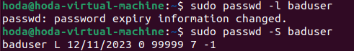

**9. Delete bad user account**

**10. Delete the supplementary group called badgroup.**

